1. **Phase 1: Problem Definition and Design Thinking**

Floods pose significant threats, causing loss of life and property damage. Timely and accurate monitoring is crucial for disaster management.IoT flood monitoring systems utilize sensors to provide real-time data on water levels. This technology enables remote monitoring and rapid response, enhancing preparedness and minimizing the impact of floods on communities.

1. **Problem Definition:**

Flooding is a natural disaster that can cause significant damage to property, infrastructure, and even loss of life. To address this issue, a Flood Monitoring System is needed to:

* Loss of Life & Property: Floods cause fatalities and extensive damage to homes and infrastructure.
* Infrastructure Disruption: Roads, bridges, and utilities are damaged, hindering rescue and relief efforts.
* Health Hazards: Contaminated water leads to diseases; inadequate sanitation worsens health risks.
* Agricultural Loss: Crops and livestock are destroyed, impacting farmers' livelihoods and food supply.
* Environmental Damage: Floods harm ecosystems, causing biodiversity loss and soil erosion

1. **Design Thinking:**

* User-Centric Approach**:** Start by understanding the needs of various stakeholders, including residents, local authorities, and emergency responders.
* Data Sources**:**
  + Integrate weather forecasts, river gauges, and rainfall data.
  + Use IoT devices like water level sensors, weather stations, and cameras.
* Data Analysis**:**
  + Implement data analytics and machine learning algorithms to predict flooding based on historical data and real-time inputs.
* Early Warning System**:**
  + Develop a notification system (e.g., mobile apps, SMS, sirens) for residents.
  + Establish protocols for authorities to take action.
* Data Visualization**:**
  + Create user-friendly dashboards displaying real-time flood data.
  + Use maps and charts to convey information effectively.
* Scalability**:**
  + Design the system to handle data from various locations.
  + Plan for future expansion as more sensors are deployed.
* Resilience**:**
  + Ensure system redundancy to minimize downtime during disasters.
  + Backup power sources for sensors and servers.
* Community Engagement**:**
  + Educate the public on flood risks and preparedness.
  + Encourage citizen reporting and data sharing.
* Legal and Ethical Considerations**:**
  + Address privacy concerns related to data collection and sharing.
  + Comply with data protection regulations.
* Continuous Improvement**:**
  + Collect feedback from users and authorities to refine the system.
  + Stay updated with the latest technology and research in flood monitoring.
* Collaboration**:**
  + Work with meteorological agencies, environmental organizations, and local governments to access data and resources.
* Cost-Efficiency**:**
  + Optimize the use of resources to ensure the system's sustainability.

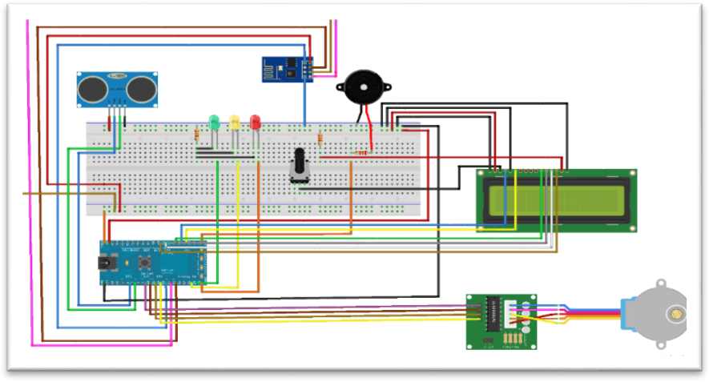Circuit Diagram:

* Install water level sensor at flood-prone area securely.
* Connect sensor to microcontroller following sensor datasheet Program microcontroller to read sensor data.
* Establish connectivity (Wi-Fi/LoRa) and send data securely.
* Create an account on chosen cloud platform.
* Configure microcontroller to send data to cloud using HTTPS/MQTT protocols.
* Implement alert system to notify when water levels exceed set threshold. Integrate weather forecasts for accurate
* Develop web interface displaying real-time data and flood alerts.
* Enable users to set alert thresholds and receive notifications. Test system extensively to ensure accurate readings and reliable alerts.
* Calibrate sensors if needed for accuracy.
* Install the system in flood-prone areas, ensuring weatherproofing.
* Regularly monitor and maintain the system for optimal performance.